Walking raw

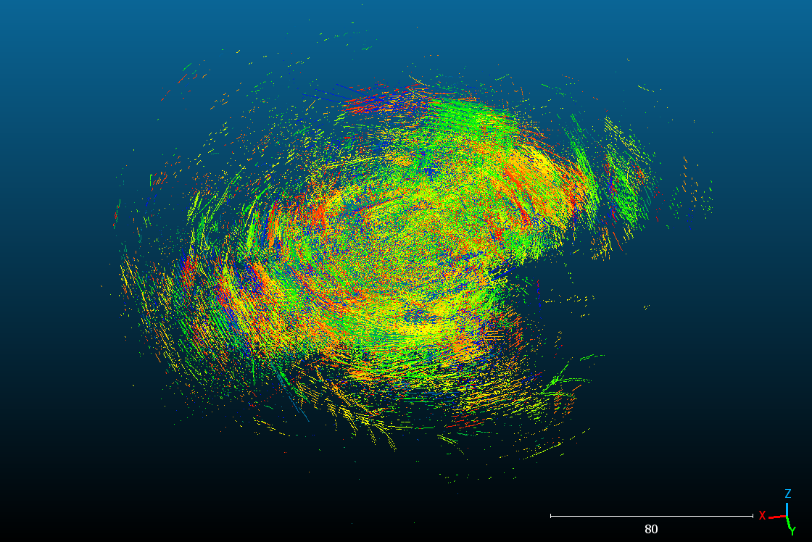

Walking processed

Garden raw

Garden processed

Park raw

Park processed

Walking raw

Walking processed

Park raw

Garden raw

Garden processed

Park processed

|  |  |  |
| --- | --- | --- |
|  | Pre SLAM | Post SLAM |
| Walk | 27,269,635 points | 14,131,343 points |
| Park | 9,841,607 points  (2) 13,459,618 points | 14,716,460 points |
| Garden | 85,737,382 points | 8,829,576 points  8,830,160 points |

|  |  |  |
| --- | --- | --- |
|  | Pre SLAM | Post SLAM |
| Walk | 27,269,635 points | 14,131,343 points |
| Park | 13,459,618 points | 14,716,460 points |
| Garden | 85,737,382 points | 8,830,160 points |